Import data using transform map using spreadsheet 

DATA FLOW DIAGRAM:
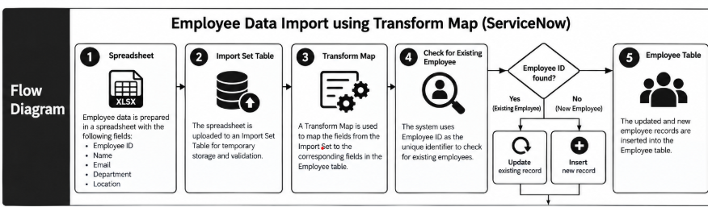

USER STORIES:

User Story 1 – Prepare Employee Data
As an HR Admin, I want to prepare an employee spreadsheet containing Employee ID, Name, Email, Department, and Location, so that employee information is ready to be imported into ServiceNow.

User Story 2 – Upload Employee Data
As an HR Admin, I want to upload the employee spreadsheet into the Import Set Table, so that the employee data can be stored temporarily and checked before it is added to the Employee table.

User Story 3 – Map Employee Fields
As a ServiceNow Admin, I want to create a Transform Map to map the spreadsheet fields to the correct Employee table fields, so that the employee information is transferred correctly.

User Story 4 – Identify Existing Employee
As a System, I want to use the Employee ID as a unique identifier to check whether an employee already exists, so that the system can decide whether to update an existing record or create a new one.

User Story 5 – Update Existing Employee
As a System, I want to update the existing employee record when the Employee ID is found, so that the employee's latest information is maintained in ServiceNow.

User Story 6 – Insert New Employee
As a System, I want to create a new employee record when the Employee ID is not found, so that new employees can be added to the Employee table.

User Story 7 – Verify Employee Data
As an HR Admin, I want to check the Employee table after the import is completed, so that I can confirm that the employee information has been imported correctly and completely.

Overall User Story
As an HR Admin, I want to import employee information from a spreadsheet into ServiceNow using Import Sets and a Transform Map, so that existing employee records can be updated using Employee ID and new employee records can be created automatically.

